***MNIST Database***

***Laboratory 12***

*Neural Networks*

Miguel Fernández Carratalá

Computer Science

Politechnika Krakowska

2019/20

***Index***

Softmax Linear….………………………………………..……………3,4

Softmax 1HL.…………………….…………………….………...……5,6

Softmax 2HL (with Regularization)..….…….………………………7,8

***Softmax Linear***

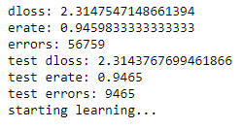

Best test error rate: 22.17%

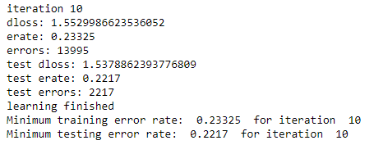

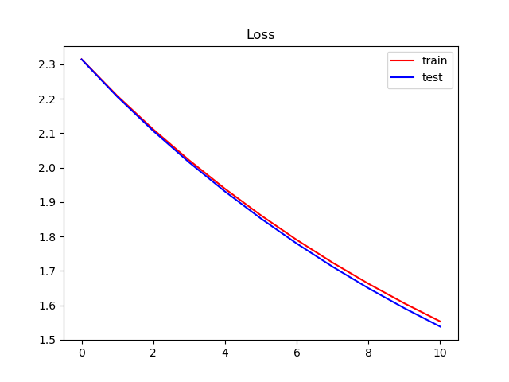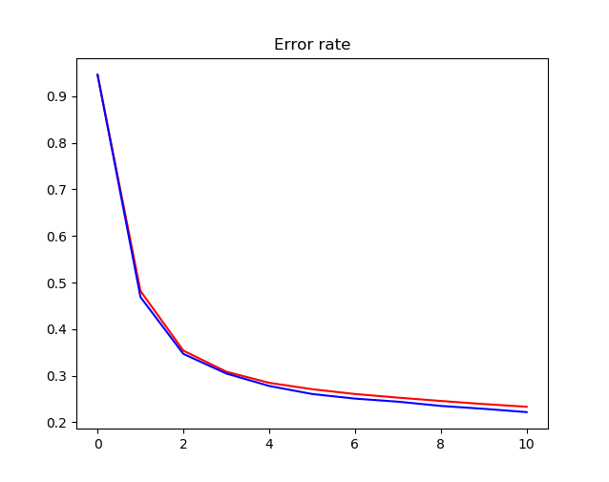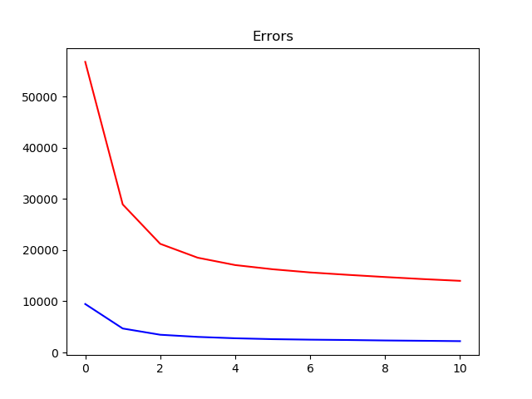

***Softmax1HL***

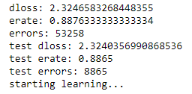

Best test error rate: 44.82%

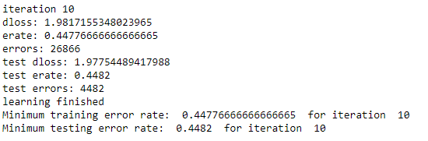

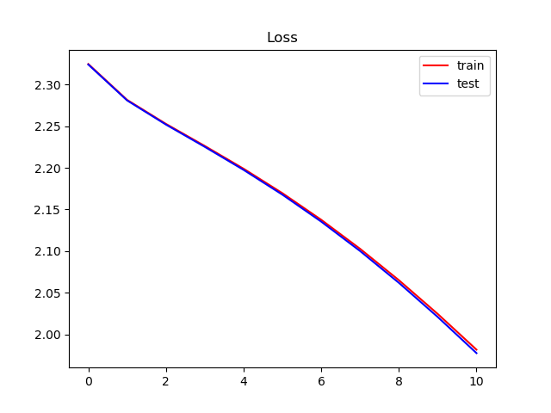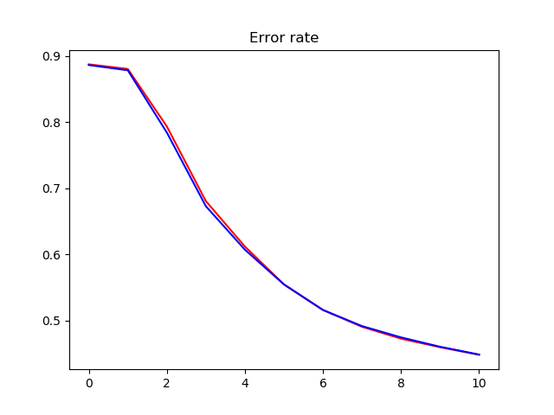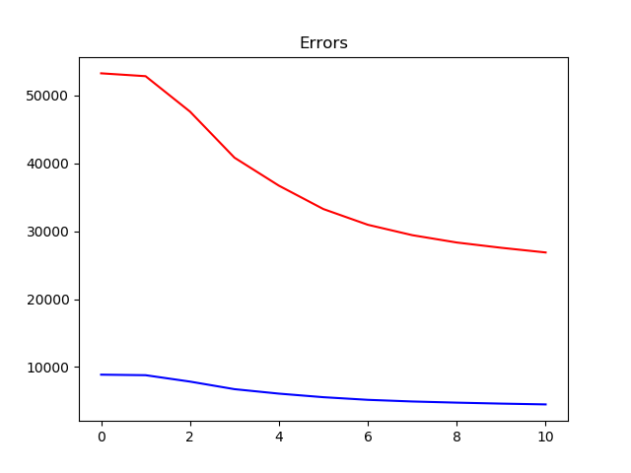

***Softmax2HL with Regularization***

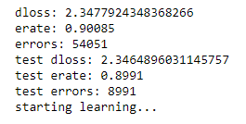

Best test error rate: 89.91%

